Oracle SQL 5&6

Katherine Hackett

4.1

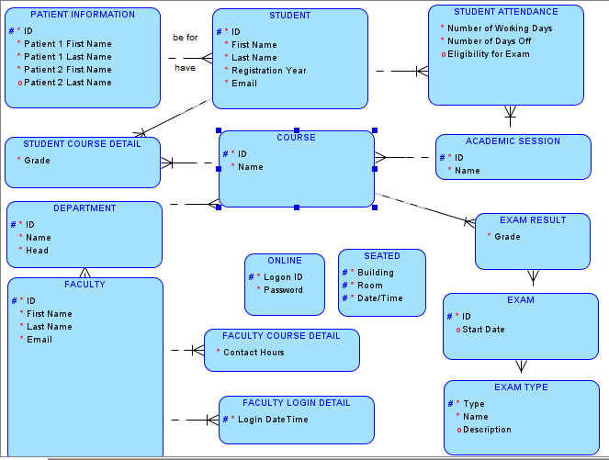

The arc related buttons are greyed out, so I can’t create the arc relationship between the course and whether it’s online or seated. I also am having trouble with the subsets for faculty. When I went into the page from the instructions, the options I wanted weren’t listed, and options I hadn’t typed in anywhere else were.

4.2

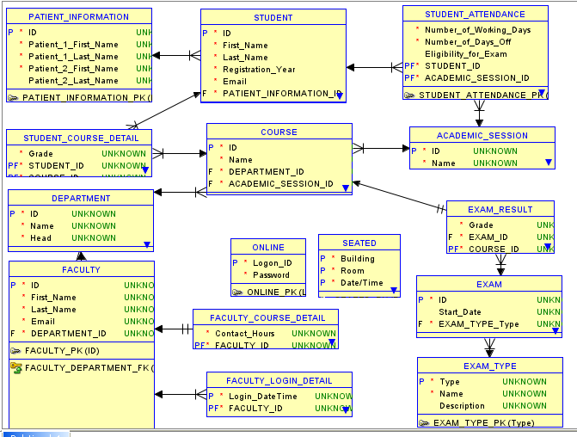

5.1

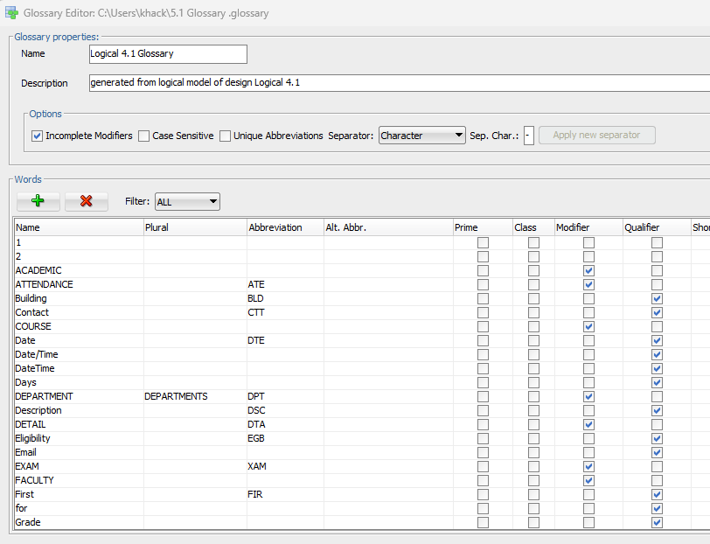

How do I view the glossary?

How do I know what to label the entities- modifier vs qualifier?

5.2

